NEXTAG COMPANY

Medium suede shoulder bag

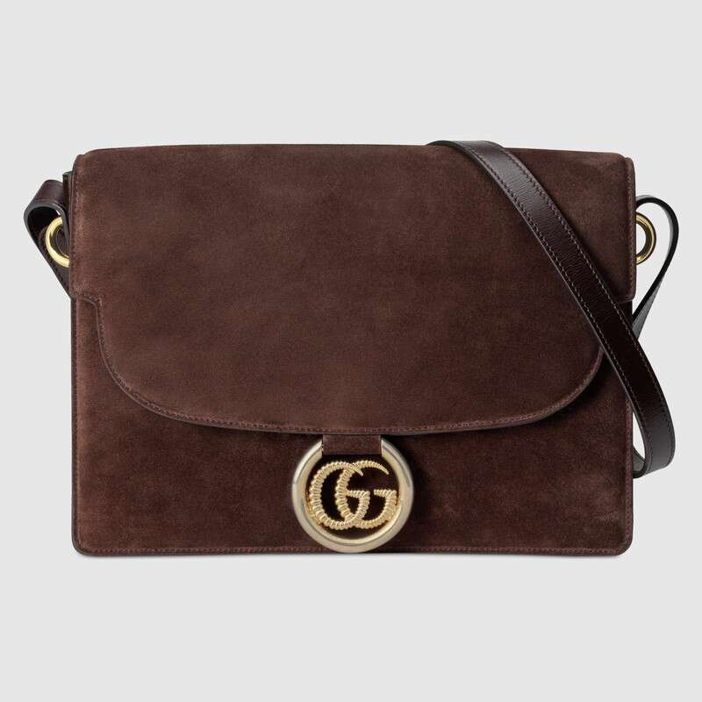

Style # 589471 1DGBG 2334

Product Description

Presented in deep brown suede, this shoulder bag introduced for Fall Winter 2019 is completed with the framed torchon Double G, which defines the line. A modern mix of shiny and antique gold-toned metal, the new emblem reintroduces the Double G with a twisted torchon finish surrounded by a ring detail. The structured shape is completed with an adjustable leather shoulder strap and a flap closure with a hidden pocket detail.

Antique and shiny gold-toned hardware • Framed torchon Double G • Adjustable shoulder strap with 16.5" drop • Open pocket under the flap • Interior zipper and smartphone pockets • Flap closure • Made in Italy

PRODUCT DETAILS

Style ‎589471 1DGBG 2334

Presented in deep brown suede, this shoulder bag introduced for Fall Winter 2019 is completed with the framed torchon Double G, which defines the line. A modern mix of shiny and antique gold-toned metal, the new emblem reintroduces the Double G with a twisted torchon finish surrounded by a ring detail. The structured shape is completed with an adjustable leather shoulder strap and a flap closure with a hidden pocket detail.

* Deep brown suede
* Antique and shiny gold-toned hardware
* Framed torchon Double G
* Open pocket under the flap
* Interior zipper and smartphone pockets
* Adjustable shoulder strap with 16.5" drop
* Flap closure
* Medium size: 11.8"W x 8.3"H x 3.7"D
* Viscose lining
* Made in Italy
* The model is 5'9" tall